**To add products to your Solutions**

Click on ‘User Administration’ from ‘My Profile’ in the top left corner of your UI screen.

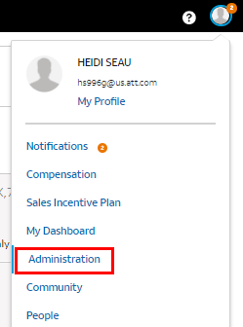

Select ‘User Administration’

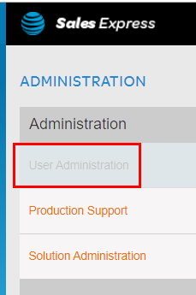

Enter your attuid

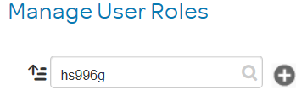

Press ‘Select’

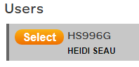

Scroll down through the options, when you find what you need click on the 

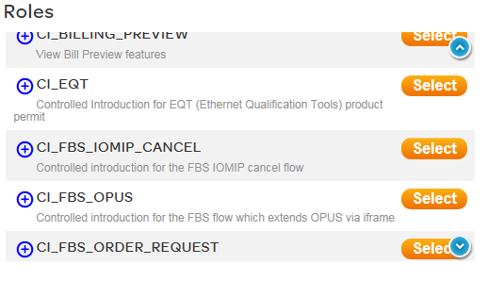

Change will be reflected once authorization catalog job process runs